**U.S. Coast Guard Academy; Department of Engineering**

**Electrical Engineering & Cyber Systems Section**

Capstone Projects in EE/CYS 1 F21

Unmanned Aerial Vehicle: Time Management Document

16 November 2021

1/c Meyers, 1/c Von Brock, 1/c Schellman, 1/c Kim, 1/c McGahey, 1/c Bulone

**Work Breakdown Structure**

1. Project Documentation
   1. Research Paper
   2. Semester Presentation
   3. GitHub Wiki
      1. Maintain with instruction to replicate project progress for future groups.
   4. Requirements Document
      1. Update requirements when the Roboboat 2022 guidelines are released.
   5. Stakeholder Management
   6. Project Budget
      1. Update with maintenance costs.
      2. Possible cost to acquire more powerful computer for SITL simulation.
      3. Possible cost for more powerful onboard image processing resources.
   7. Work Breakdown Structure
      1. Track key milestones on the WBS or Gantt chart.
   8. Status Presentations
   9. Final Presentation
   10. Final Paper
2. Hardware
   1. Base Drone Assembly
      1. Improve flight controller vibration dampener.
      2. Replace ESCs.
      3. Refine component mounts.
      4. Balance propellers.
      5. Construct a second drone for testing.
   2. Image Processing
      1. Determine the processing power requirements of image processing algorithms.
      2. Replace the Raspberry Pi 3b+ as necessary.
   3. Flotation
      1. Positive buoyance for 120 seconds (T), or indefinitely (O).
      2. Achieve IPX4 water resistance (O).
   4. Transportation of Small Objects
      1. Contingent upon the release of the Roboboat 2022 competition guidelines.
   5. Testing Equipment
      1. Acquire a more powerful computer for SITL testing with Gazebo.
   6. Safety Equipment
      1. Acquire a new drone tether for testing.
3. Software
   1. PX4 Autopilot
      1. Test and understand offboard flight modes.
      2. Test autonomous flight modes.
      3. Improve flight controller stability through tuning.
   2. Computer Vision
      1. Determine a suitable, lightweight OpenCV installation.
      2. Implement Aruco marker identification.
      3. Increase robustness and reliability of landing platform identification.
   3. Computer Vision Enabled Landing Mode
      1. Utilize OpenCV for target identification.
      2. Utilize telemetry data from flight controller.
      3. Design a MIMO controller to output desired heading and velocity.
      4. Send offboard commands to the flight controller over Mavlink.
      5. Maintain 2Hz connection (T), 30Hz (O).
   4. Communication
      1. Increase XBee bandwidth.
      2. Determine the effective range.
      3. Establish a communication protocol with the ASV.
   5. Autonomous Search
      1. Automate search pattern planning for autonomous flight.
      2. Capture images of key targets (buoys for ASV).
4. Testing
   1. Static GPS-RTK Testing
      1. Configure GPS with RTK surveyor.
      2. Establish known position on field.
      3. Test the accuracy of each mode.
   2. SITL Testing Phase III
      1. Test offboard flight modes.
      2. Test failsafe procedures.
      3. Test video capture and processing.
   3. Test Flight III
      1. Test autonomous flight modes with GPS and RTK.
      2. Test offboard flight mode.
      3. Record camera footage for computer vision analysis.
      4. Test failsafe procedures.
      5. Retune flight controller for better stability.
   4. SITL Testing Phase IV
      1. Test computer vision enabled flight and static landing.
      2. Test failsafe procedures and error conditions.
   5. Test Flight IV
      1. Test computer vision enabled flight and static landing.
      2. Retune flight controller for better stability.
      3. Test failsafe procedures and error conditions.
   6. SITL Testing Phase V
      1. Test computer vision enabled landing on moving target.
   7. Test Flight V
      1. Test computer vision enabled landing on moving target.
      2. Test payload delivery
      3. Test floatation of drone
      4. Test autonomous searching

**Network Diagram**

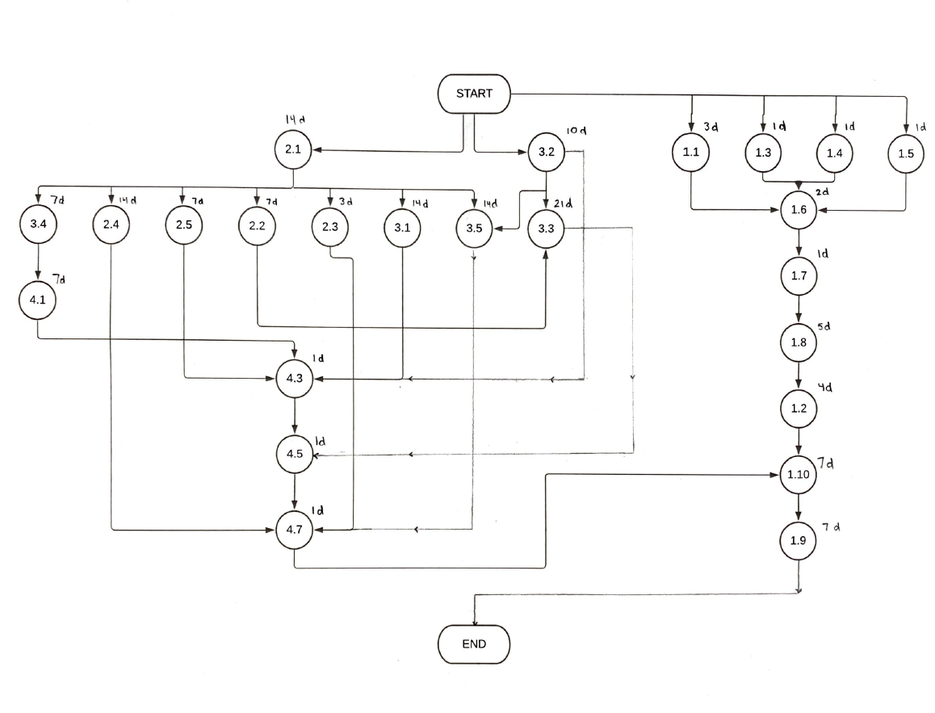**Critical Path:**

Start – 3.2 - 3.3 - 4.5 - 4.7 - 1.10 - 1.9 - End: 47

**Gantt Chart:**

Please see included Gantt Chart!